The Gingerbread Man

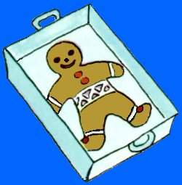
Once upon a time a little old woman and a little old man lived in a cottage. One day the little old woman made a gingerbread man. She gave him currants for eyes and cherries for buttons. She put him in the oven to bake.

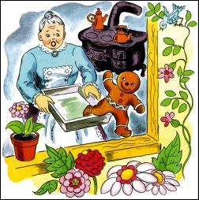
The little old woman and little old man were very hungry and wanted to eat the gingerbread man. As soon as he was cooked, the little old woman opened the oven door. The gingerbread man jumped out of the tin and ran out of the open window shouting, 'Don't eat me!'

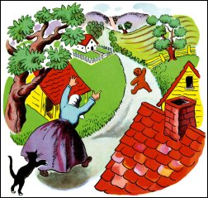
The little old woman and little old man ran after the gingerbread man.
'Stop! Stop!' they yelled. The gingerbread man did not look back. He ran on saying,
'Run, run as fast as you can! You can't catch me, I'm the gingerbread man!'

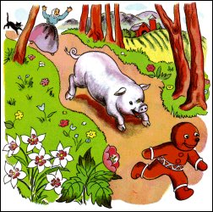
Down the lane he sped when he came to a pig. 'Stop! Stop! I would like to eat you," shouted the pig. The gingerbread man was too fast. He ran on saying
"Run, run as fast as you can. You can't catch me,
I'm the gingerbread man.

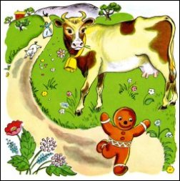
A little further on he met a cow. 'Stop! Stop! little man,' called the hungry cow, 'I want to eat you.' Again the gingerbread man was too fast. He sped on down the road saying, "Run, run as fast as you can. You can't catch me, I'm the gingerbread man."

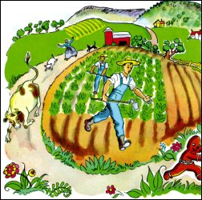
The cow began to chase the gingerbread man along with the pig, and the little old woman. But the gingerbread man was too fast for them.

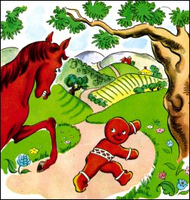
It was not long before the gingerbread man came to a horse. 'Stop! Stop!' shouted the horse. 'I want to eat you, little man.' But the gingerbread man did not stop. He said, 'Run, run as fast as you can. You can't catch me, I'm the gingerbread man.'

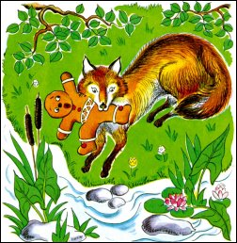
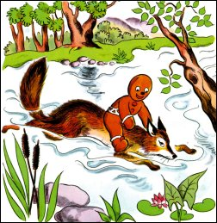
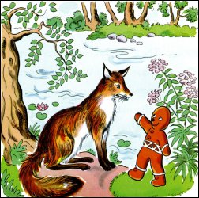
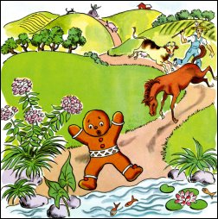
The horse joined in the chase. The gingerbread man laughed and laughed, until he came to a river. 'Oh no!' he cried, 'They will catch me. How can I cross the river?'

A sly fox came out from behind a tree. 'I can help you cross the river,' said the fox. 'Jump on to my tail and I will swim across.'
'You won't eat me, will you?' said the gingerbread man.
'Of course not,' said the fox. 'I just want to help.'

The gingerbread man climbed on the fox's tail. Soon the gingerbread man began to get wet. 'Climb onto my back,' said the fox. So the gingerbread man did. As he swam the fox said, 'You are too heavy. I am tired. Jump onto my nose.' So the gingerbread man did as he was told.

No sooner had they reached the other side, than the fox tossed the gingerbread man up in the air. He opened his mouth and 'Snap!' that was the end of the gingerbread man.

