Group 2

1..............................

2..............................

3..............................

4..............................

5..............................

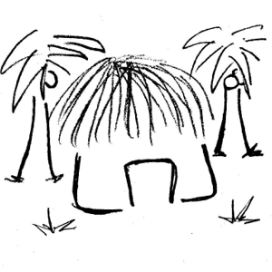

Group 1

1..............................

2..............................

3..............................

4..............................

5..............................

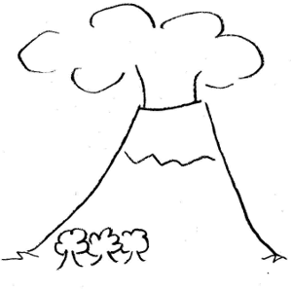

Group 4

1..............................

2..............................

3..............................

4..............................

5..............................

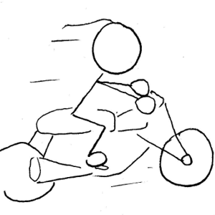

Group 3

1..............................

2..............................

3..............................

4..............................

5..............................

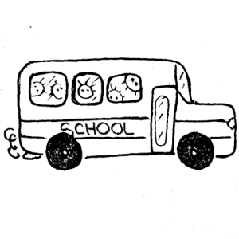

Group 6

1..............................

2..............................

3..............................

4..............................

5..............................

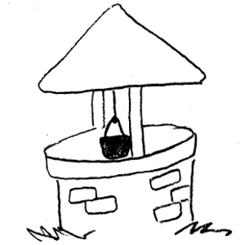

Group 5

1..............................

2..............................

3..............................

4..............................

5..............................

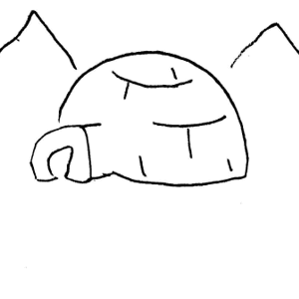

Group 7

1..............................

2..............................

3..............................

4..............................

5..............................

